**TUGAS 06**

**PRAK07 Destini App**



Praktikum Pemrograman Berbasis Web - A

Nama :

Adelia Nurlina Putri 4521210059

**PROGRAM STUDI S1 TEKNIK INFORMATIKA**

**FAKULTAS TEKNIK**

**UNIVERSITAS PANCASILA**

**JAKARTA**

**2024**

1. **Project destini_app**
   1. **First Initialization**
2. Akses web <https://docs.flutter.dev/ui/layout/tutorial>
3. Buka Android Studio

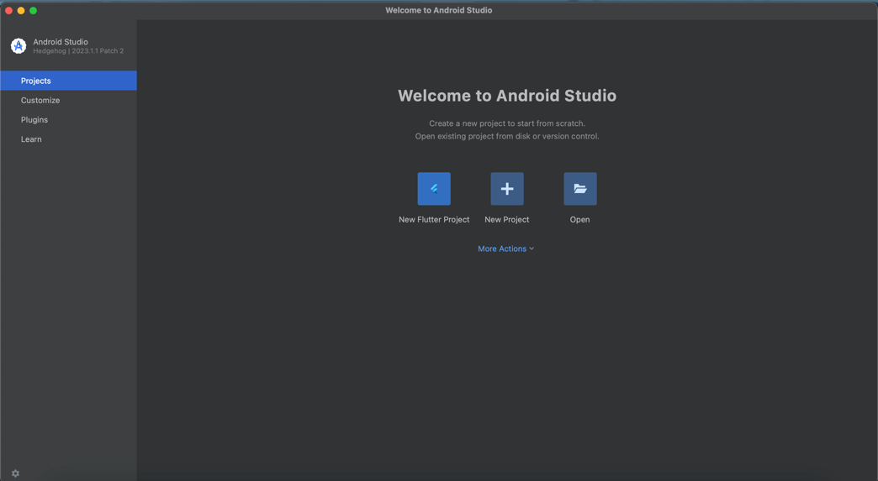

1. Pilih New Flutter Project -> Flutter -> Next

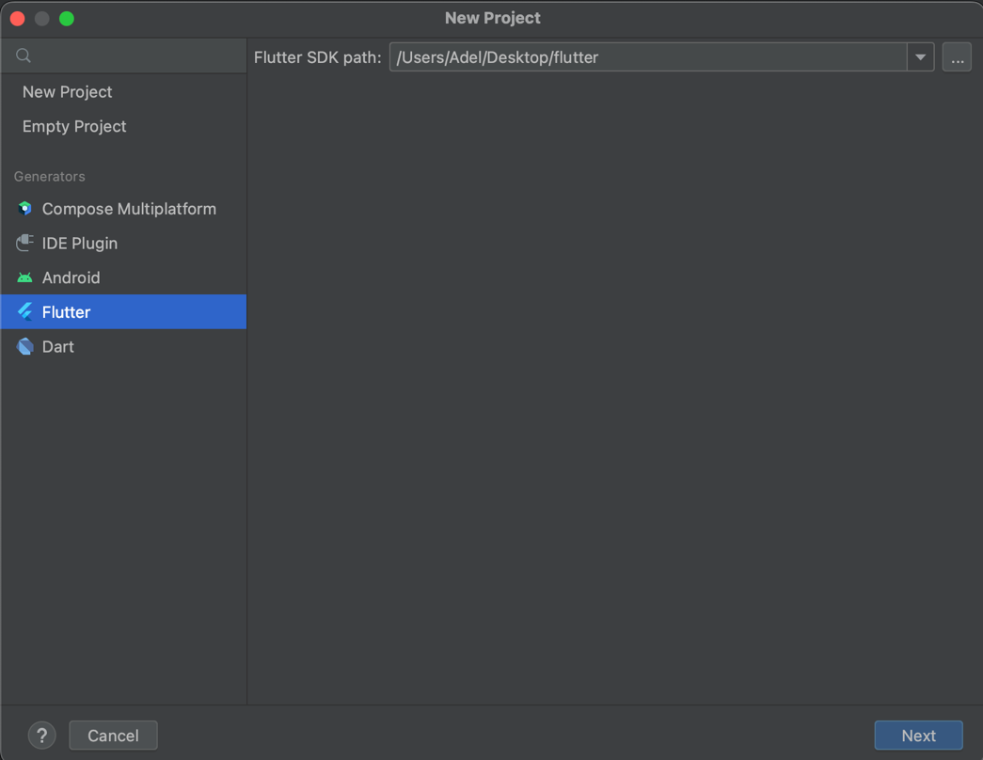

1. Isi form untuk nama project, tempat project, type, bahasa pemrograman, platforms dan lainnya -> Create

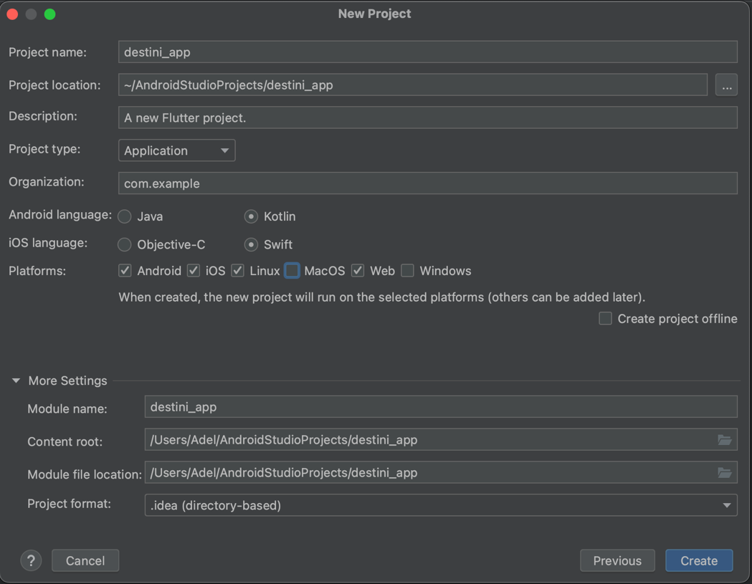

* 1. **Membuat Layout Dasar**

1. File main.dart

|  |
| --- |
| import 'package:flutter/material.dart'; import 'story_brain.dart';  void main() {  runApp(DestiniApp()); }  class DestiniApp extends StatelessWidget {  @override  Widget build(BuildContext context) {  return MaterialApp(  theme: ThemeData.dark(),  home: StoryPage(),  );  } }  class StoryPage extends StatefulWidget {  @override  _StoryPageState createState() => _StoryPageState(); }  class _StoryPageState extends State<StoryPage> {  StoryBrain storyBrain = StoryBrain();   @override  Widget build(BuildContext context) {  return Scaffold(  body: Container(  decoration: BoxDecoration(  image: DecorationImage(  image: AssetImage('images/img.png'),  fit: BoxFit.cover,  ),  ),  padding: EdgeInsets.symmetric(vertical: 50.0, horizontal: 15.0),  constraints: BoxConstraints.expand(),  child: SafeArea(  child: Column(  crossAxisAlignment: CrossAxisAlignment.stretch,  children: <Widget>[  Expanded(  flex: 12,  child: Center(  child: Text(  storyBrain.getStory(),  style: TextStyle(  fontSize: 25.0,  color: Colors.*black*,  ),  ),  ),  ),  Expanded(  flex: 2,  child: TextButton(  style: TextButton.*styleFrom*(  backgroundColor: Colors.*lightBlueAccent*,  elevation: 2,  textStyle: TextStyle(fontSize: 20.0),  ),  onPressed: () {  setState(() {  storyBrain.nextStory(1);  });  },  child: Text(  storyBrain.getChoice1(),  style: TextStyle(  fontSize: 20.0,  color: Colors.*black*,  ),  ),  ),  ),  SizedBox(  height: 20.0,  ),  Expanded(  flex: 2,  child: Visibility(  visible: storyBrain.buttonShouldBeVisible(),  child: TextButton(  style: TextButton.*styleFrom*(  backgroundColor: Colors.*white*,  textStyle: TextStyle(fontSize: 20.0),  ),  onPressed: () {  setState(() {  storyBrain.nextStory(2);  });  },  child: Text(  storyBrain.getChoice2(),  style: TextStyle(  fontSize: 20.0,  color: Colors.*black*,  ),  ),  ),  ),  ),  ],  ),  ),  ),  );  } } |

* + - * Import file story_brain.dart
      * Pada main() function runApp(DestiniApp())
      * Class DestiniApp adalah extends dari StatelessWidget
      * Return dari class DestiniApp adalah MaterialApp yang di dalamnya terdapat property home:
      * Home: memanggil class StoryPage()
      * Class StoryPage() berisi:
        1. AppBar backgroundColor dengan tema default dari ThemeData.dark()
        2. Body Container dengan BoxDecoration yang menggunakan gambar sebagai background (img.png)
        3. Terakhir berisi Column

1. File story.dart

|  |
| --- |
| class Story {  String storyTitle;  String choice1;  String choice2;   Story({  required this.storyTitle,  required this.choice1,  required this.choice2,  }); } |

* + - * Membuat class Story
      * Class Story memiliki tiga properties:
        1. storyTitle: judul atau teks utama dari cerita
        2. choice1: teks pilihan pertama
        3. choice2: teks pilihan kedua
      * Membuat constructor untuk class Story

1. File story_brain.dart

|  |
| --- |
| import 'story.dart';  class StoryBrain {  final List<Story> _storyData = [  Story(  storyTitle:  'You have won a backstage pass to an NCT 127 concert! As you walk in, you see Taeyong and Doyoung discussing their next song. They notice you and invite you to join them.',  choice1: 'Join the conversation with Taeyong and Doyoung.',  choice2: 'Excitedly ask for a photo with them.',  ),  Story(  storyTitle: 'Taeyong and Doyoung smile and welcome you to their discussion. They ask for your opinion on their new song idea.',  choice1: 'Give them a suggestion for their song.',  choice2: 'Thank them and move on to explore the backstage.',  ),  Story(  storyTitle:  'You take a photo with Taeyong and Doyoung. Just then, Johnny walks by and asks if you want to join the rest of the members for a group photo.',  choice1: 'Join the group photo.',  choice2: 'Politely decline and explore the backstage.',  ),  Story(  storyTitle:  'They love your suggestion and decide to incorporate it into their song. You end up spending the whole evening with NCT 127, helping them and learning about their creative process.',  choice1: 'Restart',  choice2: '',  ),  Story(  storyTitle:  'You explore the backstage and stumble upon a rehearsal session. You quietly watch as they practice, amazed by their talent and dedication.',  choice1: 'Restart',  choice2: '',  ),  Story(  storyTitle:  'You join the group photo and the members thank you for being a great fan. The experience leaves you with unforgettable memories and a bunch of photos to cherish.',  choice1: 'Restart',  choice2: '',  ),  ];   int _storyNumber = 0;   String getStory() {  return _storyData[_storyNumber].storyTitle;  }   String getChoice1() {  return _storyData[_storyNumber].choice1;  }   String getChoice2() {  return _storyData[_storyNumber].choice2;  }   void nextStory(int choiceNumber) {  if (_storyNumber == 0 && choiceNumber == 1) {  _storyNumber = 1;  } else if (_storyNumber == 0 && choiceNumber == 2) {  _storyNumber = 2;  } else if (_storyNumber == 1 && choiceNumber == 1) {  _storyNumber = 3;  } else if (_storyNumber == 1 && choiceNumber == 2) {  _storyNumber = 4;  } else if (_storyNumber == 2 && choiceNumber == 1) {  _storyNumber = 5;  } else if (_storyNumber == 2 && choiceNumber == 2) {  _storyNumber = 4;  } else if (_storyNumber >= 3) {  restart();  }  }   void restart() {  _storyNumber = 0;  }   bool buttonShouldBeVisible() {  return _storyNumber < 3;  } } |

* + - * Import file story.dart
      * Membuat class StoryBrain
      * StoryBrain memiliki property _storyData
      * _storyData berisi beberapa cerita dengan judul, pilihan pertama, dan pilihan kedua yang berbeda
      * Membuat property _storyNumber untuk mengetahui indeks cerita saat ini dalam _storyData
      * Membuat method getStory() yang mengembalikan storyTitle dari objek Story pada indeks _storyNumber
      * Membuat method getChoice1() yang mengembalikan choice1 dari objek Story pada indeks _storyNumber
      * Membuat method getChoice2() yang mengembalikan choice2 dari objek Story pada indeks _storyNumber
      * Membuat method nextStory(int choiceNumber) yang memperbarui _storyNumber berdasarkan pilihan untuk lanjut ke cerita selanjutnya
      * Membuat method restart() untuk mengatur _storyNumber agar kembali ke 0, digunakan saat cerita selesai

1. Membuat Directory Images

|  |
| --- |
| Klik kanan project -> New -> Directory -> Copy images to directory |

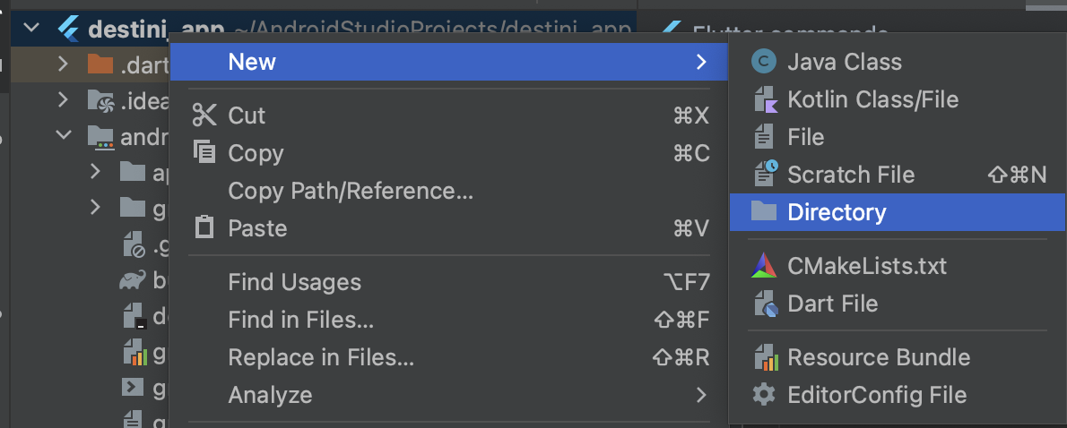

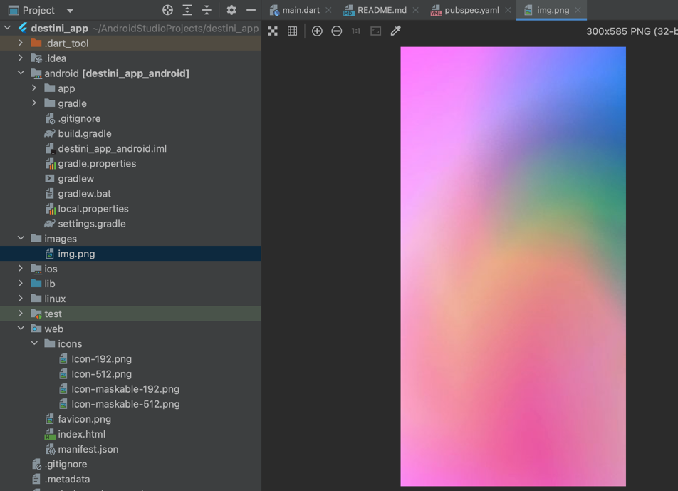

1. Menambahkan asset pada pubspec.yaml

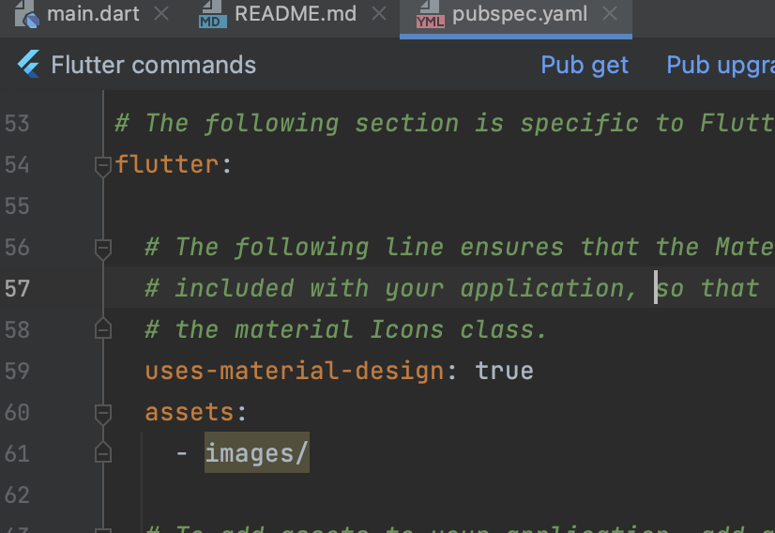

1. Update asset

|  |
| --- |
| $ flutter pub get |

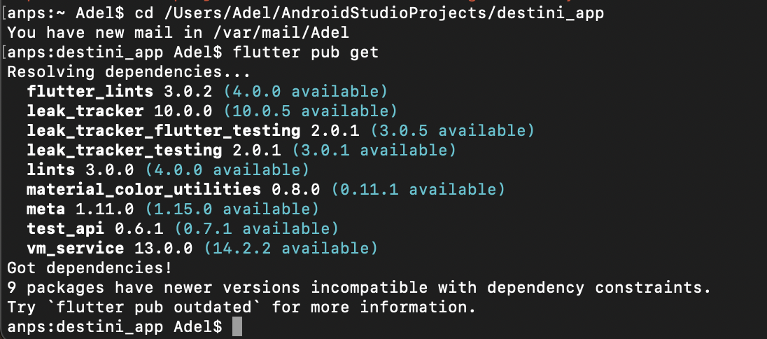

1. Run

|  |
| --- |
| Pilih Simulator -> Klik Ikon Run |

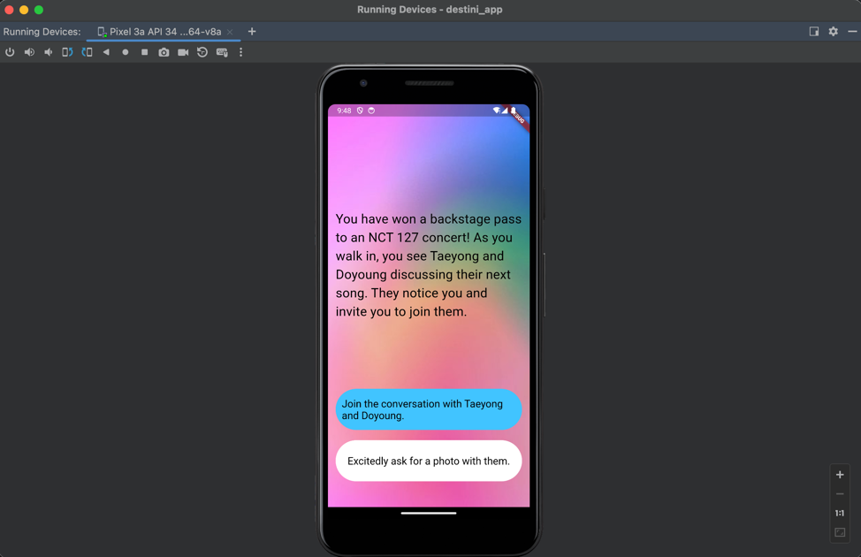

* 1. **Push Code to GitHub** <https://github.com/adelianurlinap/Prak_PBM.git>
     1. Clone Repository yang telah dibuat :

|  |
| --- |
| git clone https://github.com/adelianurlinap/Prak_PBM.git |

* + 1. Add dan commit

|  |
| --- |
| git add .  git commit -m "Tugas6" |

* + 1. Push code

|  |
| --- |
| git push |

1. **Kesimpulan**

Pada tugas 6 ini, telah dilakukan praktek untuk membuat stateful widget untuk membuat aplikasi cerita interaktif

1. **Referensi**

<https://github.com/adiwp/MobileProjects>